Aim:

To study and Implement Containerization using Docker.

Theory:

Docker is a platform for developing, shipping, and running applications using containerization technology. Containers are lightweight, portable, and self-contained environments that include all the necessary dependencies, libraries, and configuration settings needed to run an application. Docker enables developers to package their applications into containers, which can be easily distributed and run on any platform that supports Docker.

To use Docker, developers can create a Dockerfile, which is a script that defines the dependencies, libraries, and configuration settings needed to run the application. They can then build a Docker image from the Dockerfile, which includes all the necessary files and settings needed to run the application in a container. The Docker image can be pushed to a Docker registry, such as Docker Hub, where it can be easily shared and downloaded by others.

In Docker, an image is a lightweight, standalone, executable package that includes all the necessary dependencies, libraries, and configuration settings needed to run an application. It is created from a Dockerfile, which is a script that defines the instructions to build the image.

An image is like a snapshot of an application and its environment at a specific point in time. Once an image is built, it can be used to create and run one or more instances of a container. Each container runs in its own isolated environment but shares the same base image.

Images are stored in a Docker registry, such as Docker Hub, which is a public or private repository for Docker images. Docker Hub is the default public registry for Docker images and contains thousands of pre-built images that can be easily downloaded and used by developers.

Implementation:

Docker

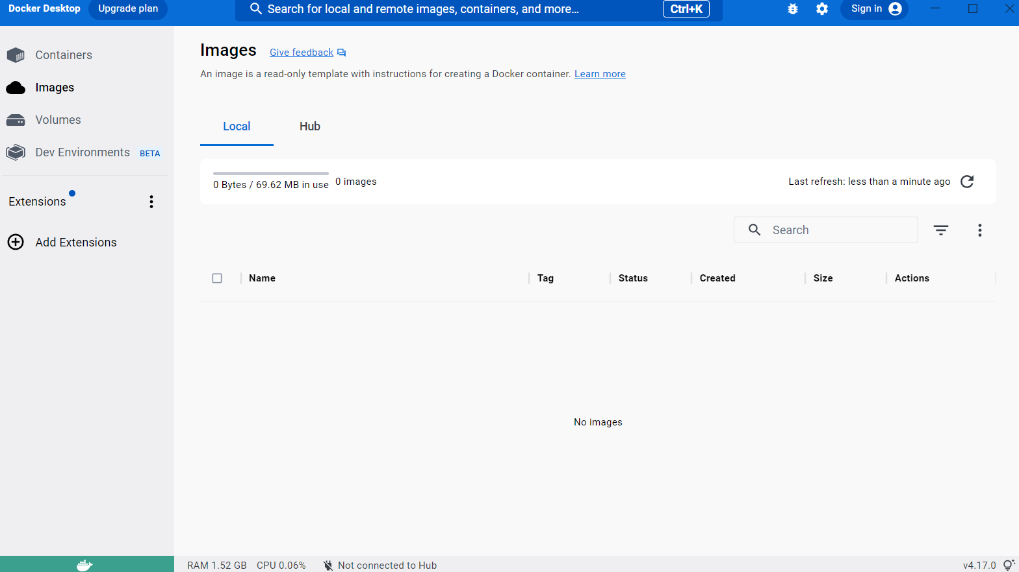

Dockerfile:

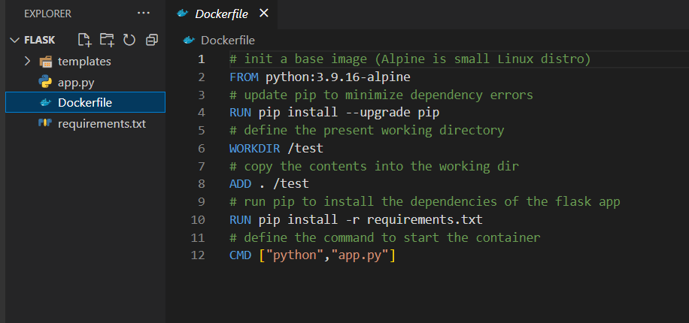

Image created at docker:



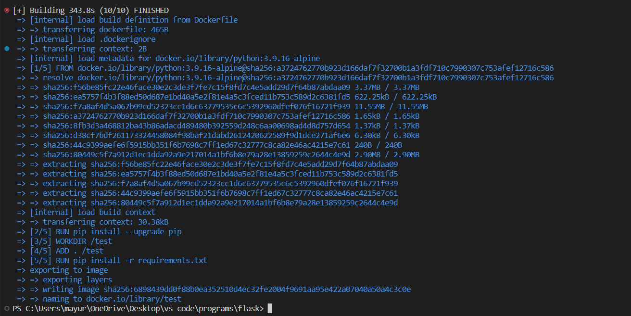

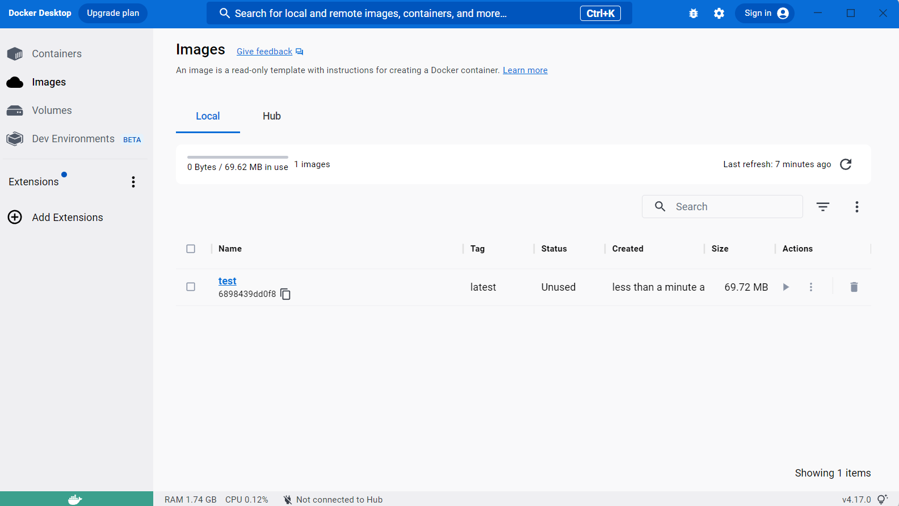



Docker hub:

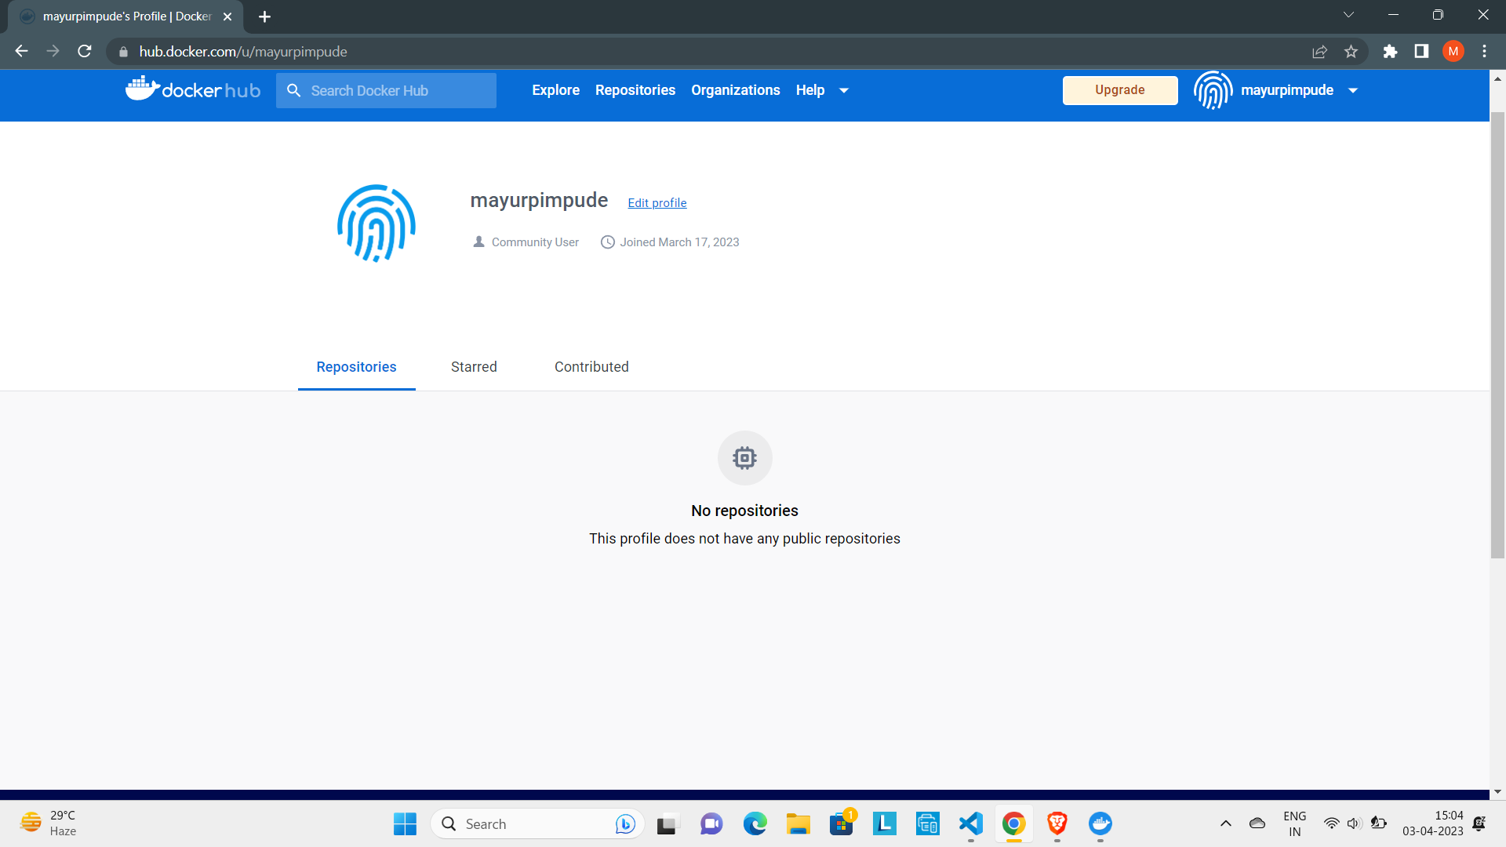

Creating docker repo

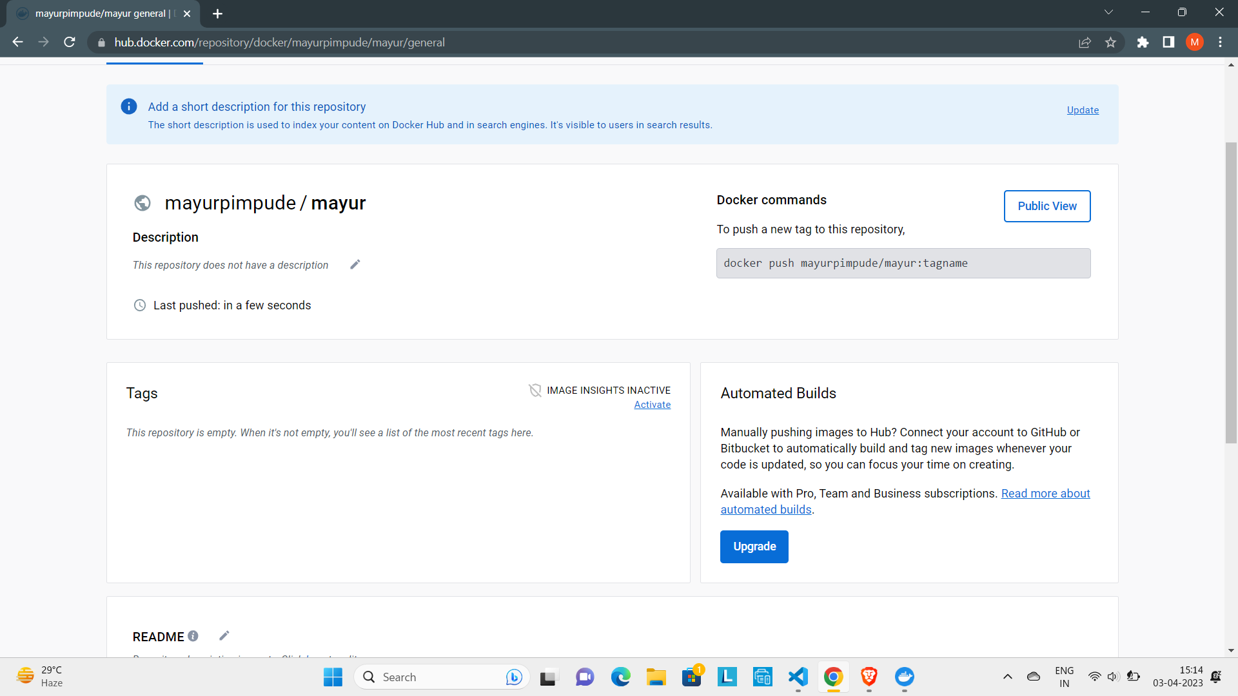

Docker push

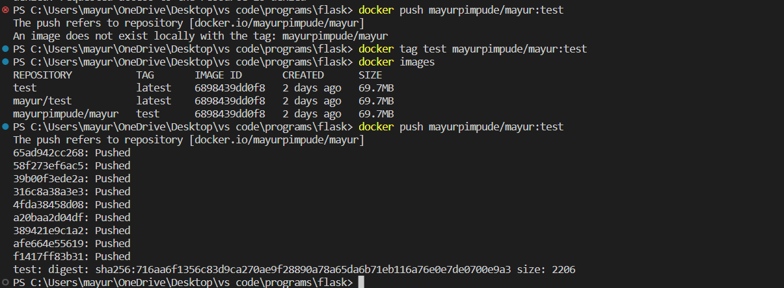

Docker image pushed to hub

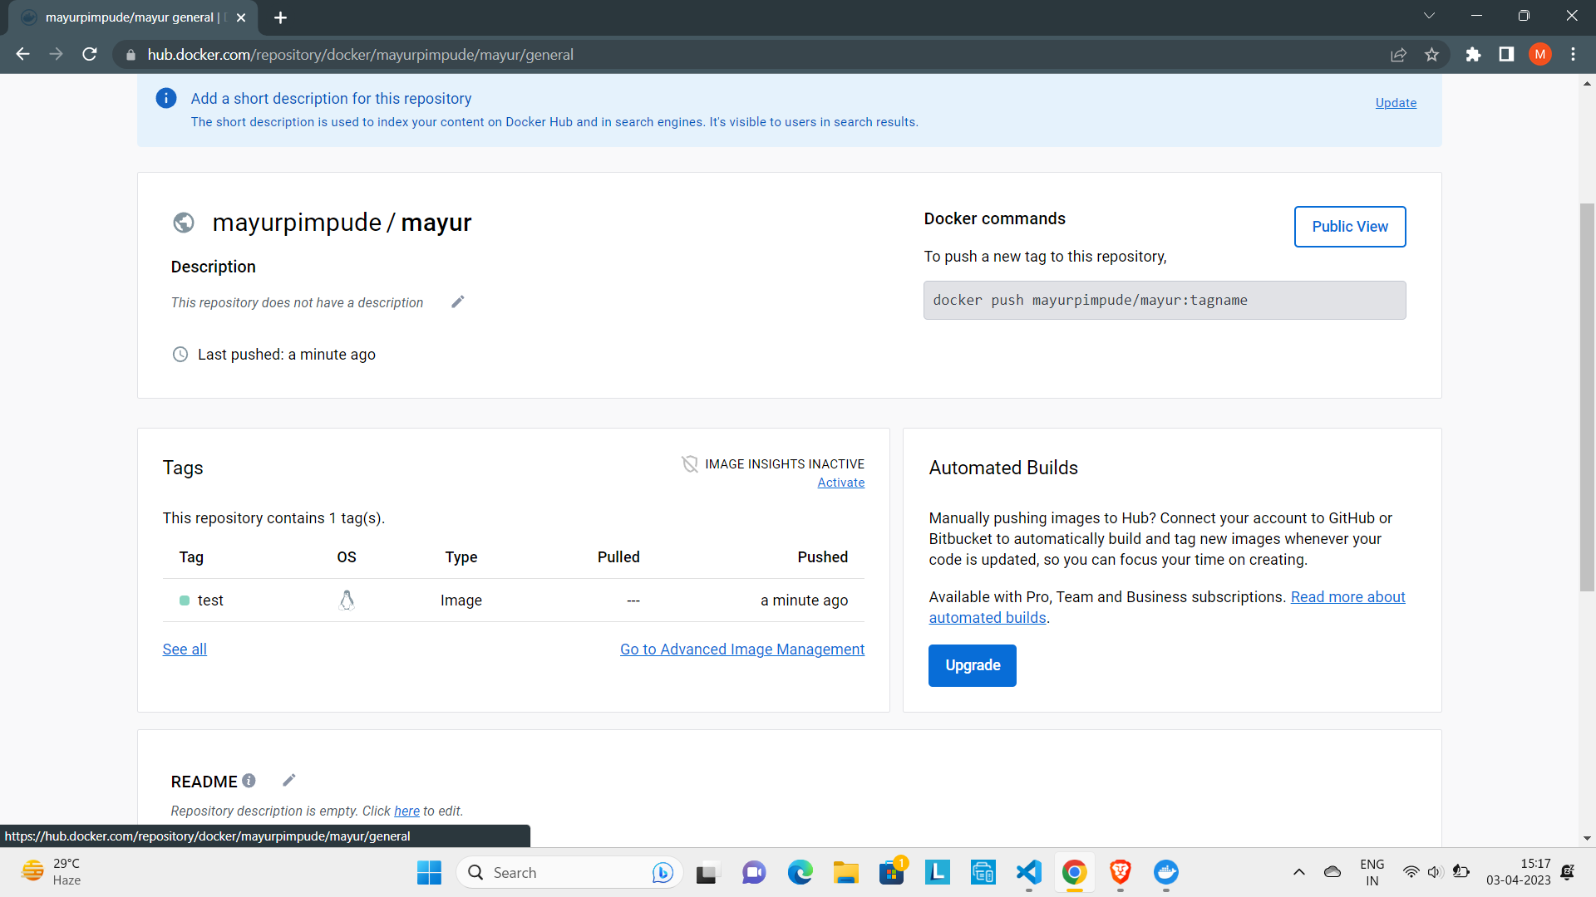

Docker image removed and then pulled from hub:

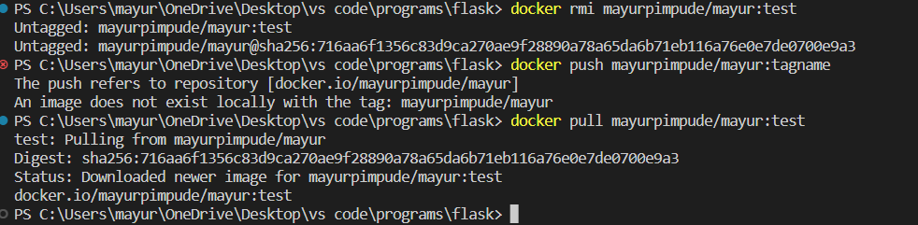

Docker Image is running on port 5000 :



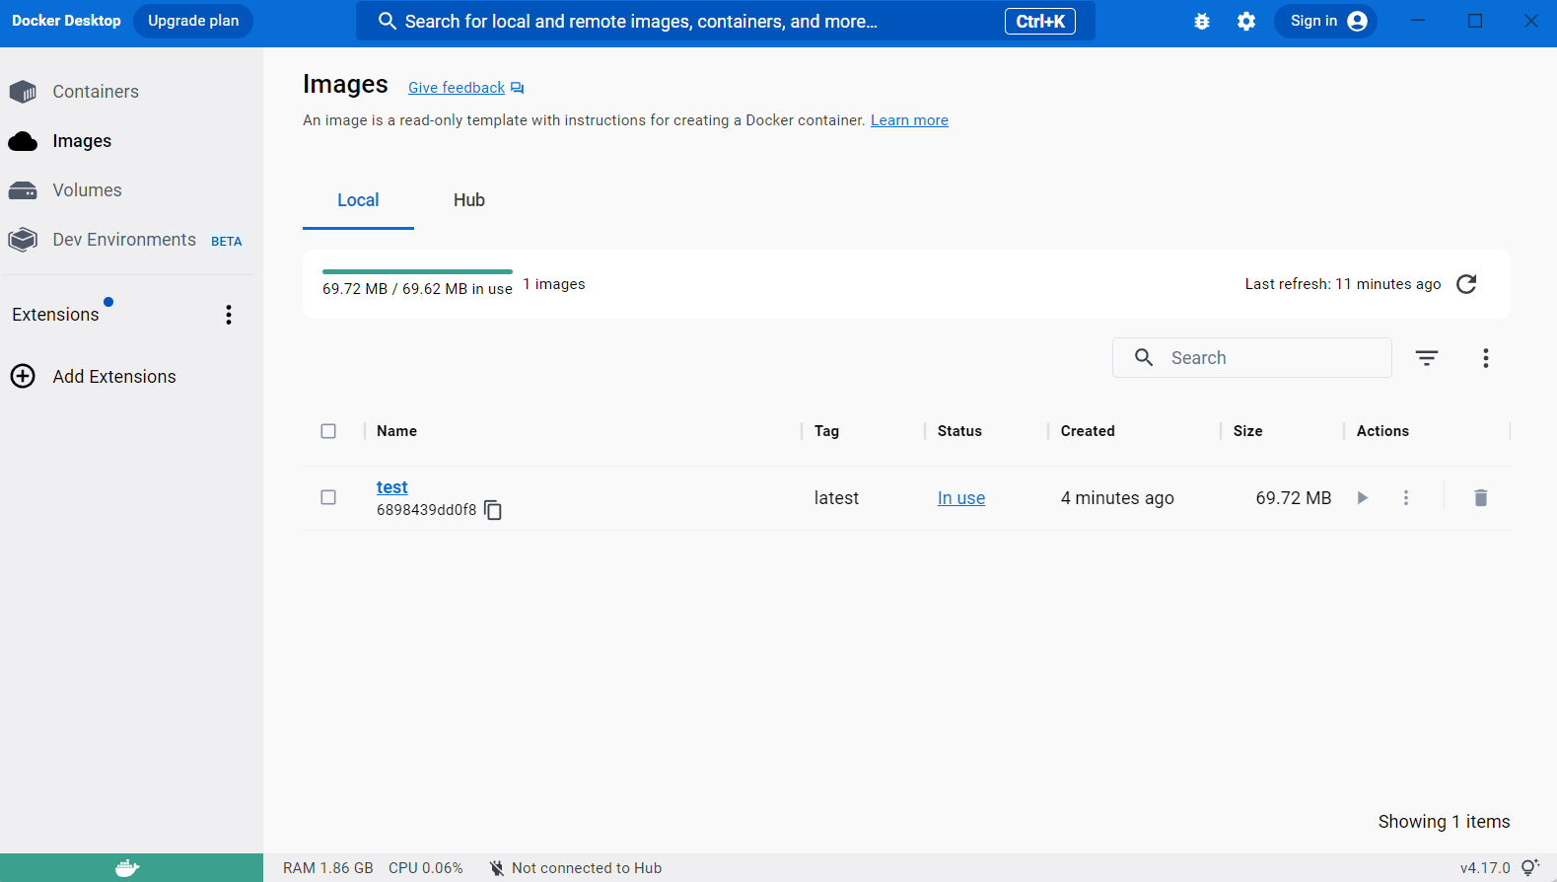

Running on Docker :

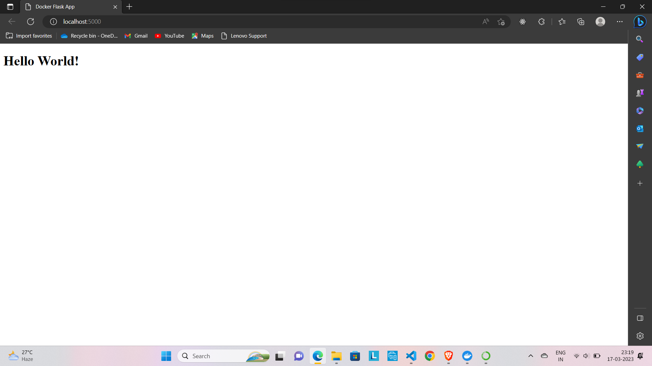

Docker image stopped :



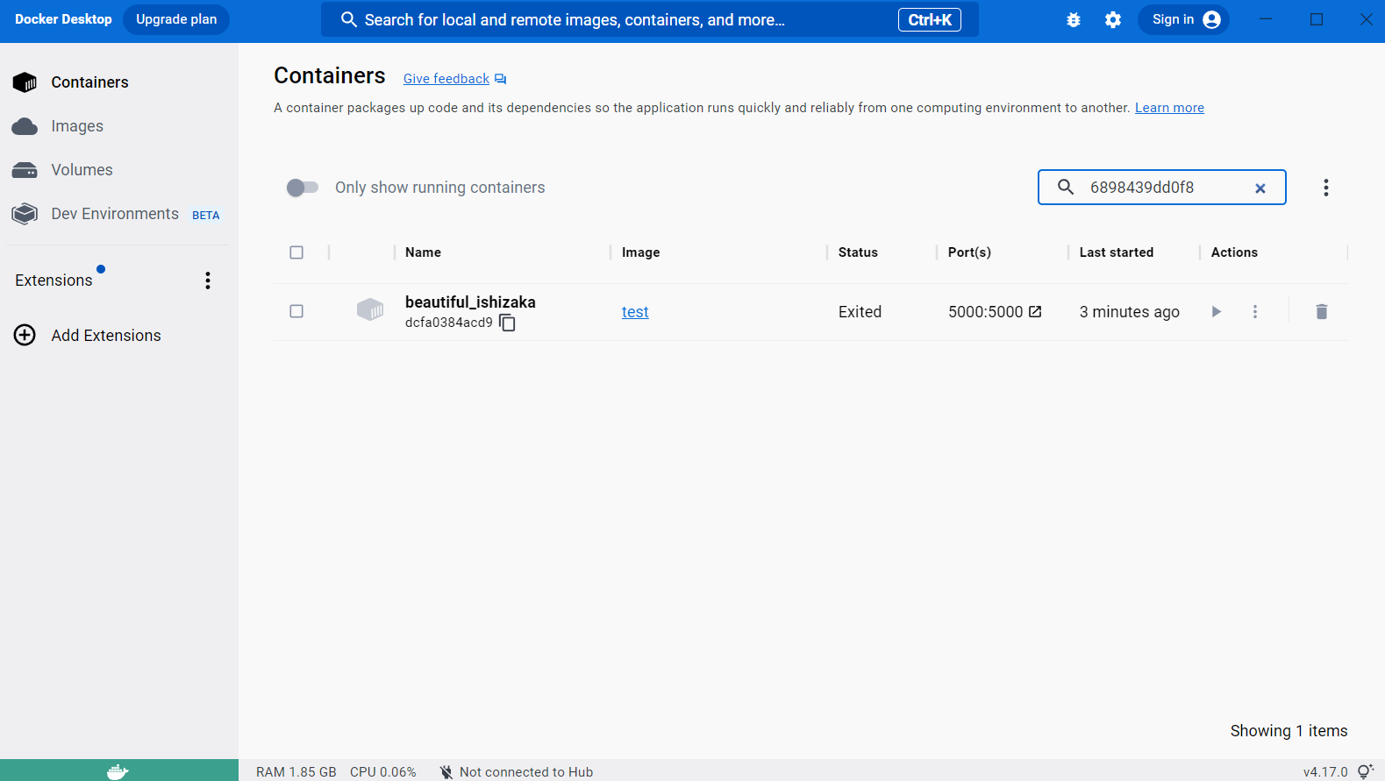

Conclusion:

In this experiment we learned about docker and implemented the docker image successful and also pushed and pulled the image of docker.